Final Project Documentation – Bionic Reading Web App
Project Overview
This project is a Bionic Reading Web Application that allows users to convert text and uploaded documents into a bionic reading format, track reading progress, and export results as PDF. The system combines frontend interactivity, backend PHP logic, database persistence, and a refined UI to deliver a complete reading experience.

Development Timeline
7th – Project Kickoff (Night Session)
- Created the core project structure with three main files:
  - index.php
  - script.js
  - style.css
- Implemented the entry point of the application.
- Added a textarea that allows users to input any text for conversion into bionic reading format.
- Initial bionic conversion logic worked 100% as expected.

8th – File Upload & Parsing (.docx)
- Implemented file upload functionality.
- Focused on commonly used student document formats.
- Started with .docx support.
- Integrated a PHP parser library using PHPWord.
- Installed the required dependency via Composer:
- composer require phpoffice/phpword
- For systems without Composer, installation was handled via the official installer.
- Successfully enabled .docx upload → parse → bionic conversion.

9th – Linguistic Upgrade: Syllable-Based Bolding
- Abandoned the basic 40% word bolding approach.
- Implemented direct syllable bolding, which is more linguistically accurate.
- Integrated Hyphenopoly for reliable syllable detection.
- This significantly improved readability and correctness of the bionic format.

10th – UI Overhaul (Glassmorphism)
- Decided the UI needed a major redesign.
- Moved away from a basic Bootstrap look.
- Introduced a custom Glassmorphism aesthetic.
- Created modular CSS files:
  - base.css – global variables and color palette (Teal & Gold)
  - layout.css – structural layout styles
  - landing.css – landing page–specific styling

11th – User Authentication System
- Implemented secure user authentication.
- Created:
  - register.php
  - login.php
- Used password_hash() for password security.
- Added form validation to enforce stronger password patterns (mixed characters).

12th – Database Schema Design
- Designed the core database schema:
  - br_users
  - br_documents
  - br_reading_sessions
- Defined relationships:
  - One User → many Documents
  - One Document → many Reading Sessions

13th – Dashboard Development
- Built the user dashboard at views/dashboard.php.
- Dashboard features:
  - Fetches user reading sessions from the database
  - Displays sessions using glass-style cards
- Implemented progress calculation:
- progress = current_word_index / total_word_count

14th – Core Logic & Autosave (ajax_handler.php)
- Implemented the core backend logic in ajax_handler.php.
- Enabled autosaving reading progress without page reloads.
- Used JavaScript fetch() to periodically send:
  - Current word index
  - Reading time
- Data is saved every few seconds, ensuring robustness.
- This was the most challenging part of the project.

15th – PDF Export Feature
- Implemented PDF export using html2pdf.js.
- Converts the bionic-reading HTML container into a downloadable PDF.
- Adjusted CSS so faded text appears correctly in exported PDFs.

16th – Deployment Attempt #1 (Failure)
- Deployed the project to the school server.
- Encountered widespread 500 Internal Server Errors.
- Root cause: significant differences between localhost and server environment.

17th – Debugging & Database Refactor
- Identified a critical table naming issue.
- Local database used unprefixed table names.
- Server required all tables to use the br_ prefix.
- Refactored SQL queries across:
  - ajax_handler.php
  - functions.php
- Entire day spent fixing compatibility issues.

18th – Reading Experience Refinements
- Fixed crashes caused by the Pause & Save button.
- Issue was due to enum mismatch:
  - in_progress vs progress
- Added Delete Reading Session functionality that was previously skipped.

19th – UI Polishing & Bug Fixes
- Fixed Try Demo live preview on the landing page.
- Resolved a dashboard grey box bug caused by an incorrect variable name.
- Improved typography:
  - Bold text appeared too faded on some screens
  - Added Inter font weight 800 for clarity

18th – Project Completion
Final walkthrough confirmed all features are fully functional:
- Upload & Parse (.docx / .pdf)
- Bionic Conversion (Hyphenopoly)
- Authentication & Database Security
- Robust Progress Autosaving
- Clean PDF Export

Project is complete and ready for submission.
Parts where AI was used in the project:
Below is my first code for the convert function. It did not follow any linguistic rule; it simply bolded 40% of a word. Then I did more research with the Claude AI model on Sonnet 4.5
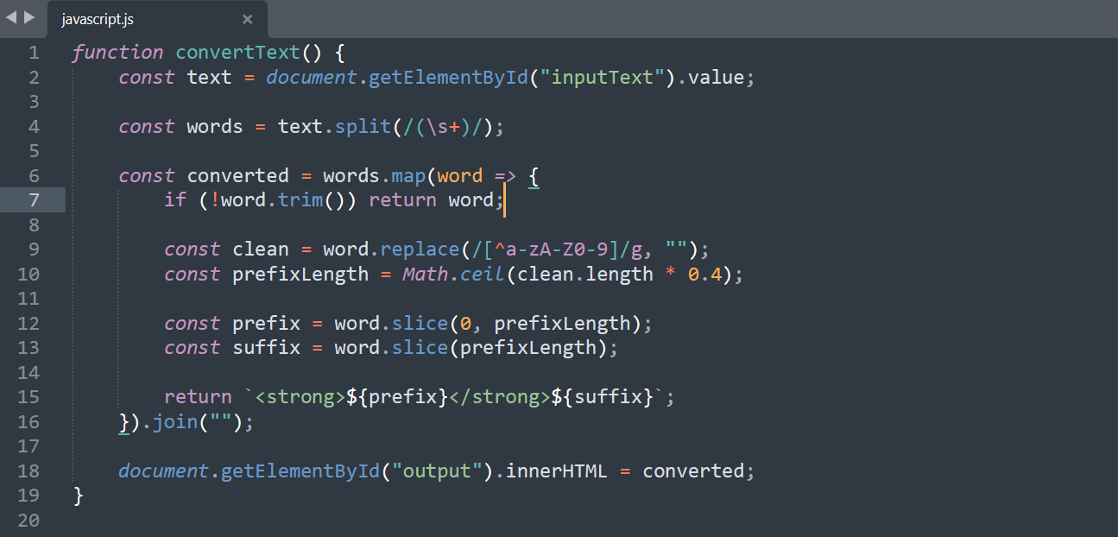
Tested this in the textarea
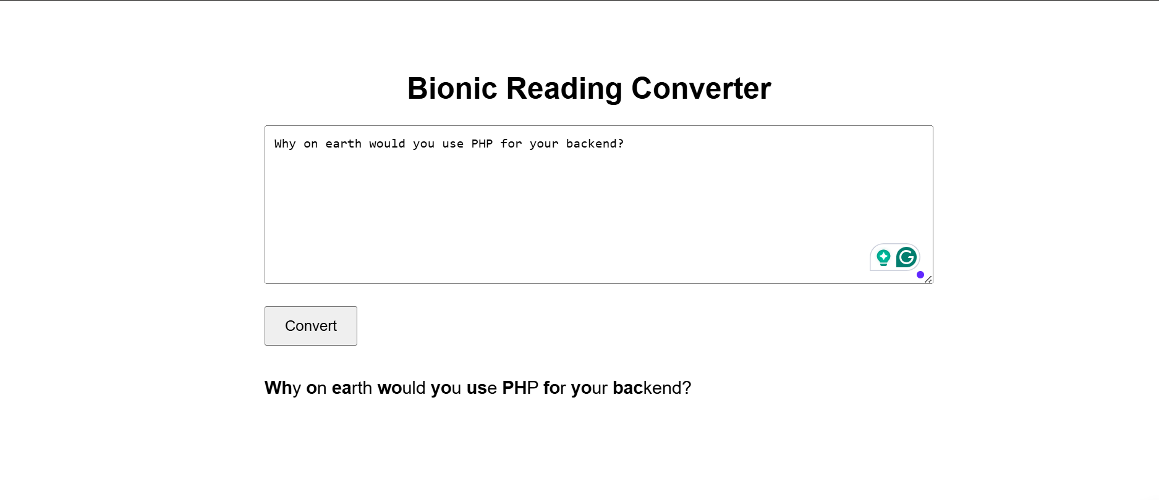
implementing the feature for file upload, common files for most students docx and pdf. Thing to lead in a parser library in php
first of all started with .docx implementation. I need phpword required library. Navigate to your project folder on CMD and run this composer require phpoffice/phpword
if don’t have composer download here, https://getcomposer.org/Composer-Setup.exe

